Day 9

Class Exercise 1

@PostMapping("/api/person")

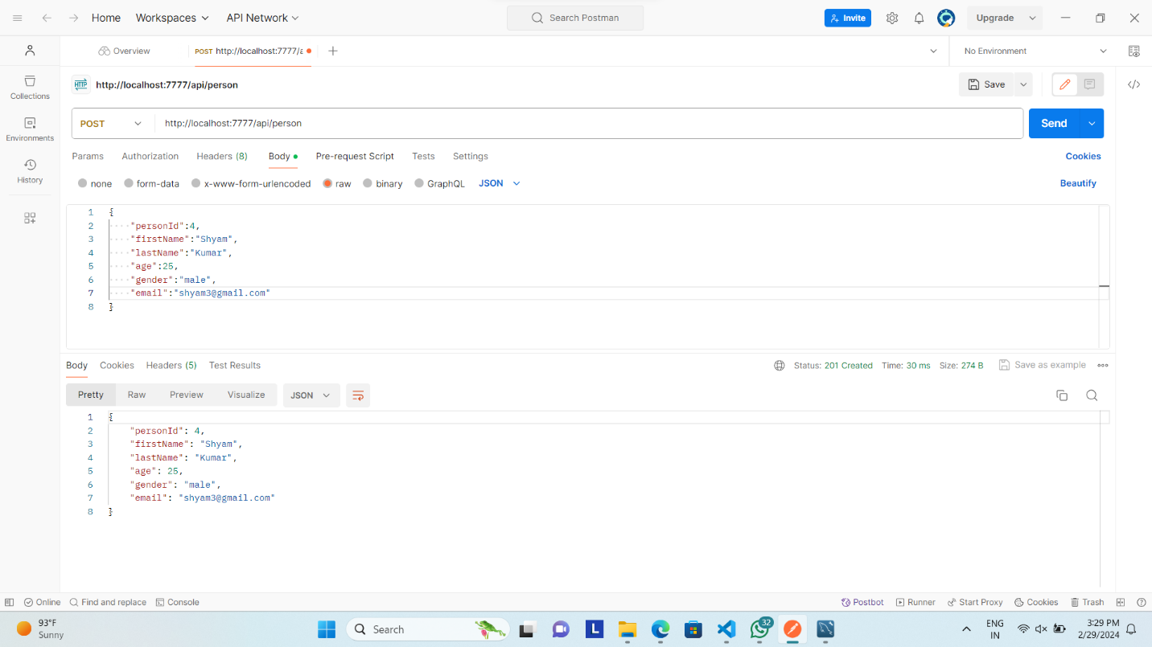

@GetMapping("/api/person/byage/{age}")

